Aotea College Media Studies Department
10822 Provide photos for news stories and features
Student Exemplar

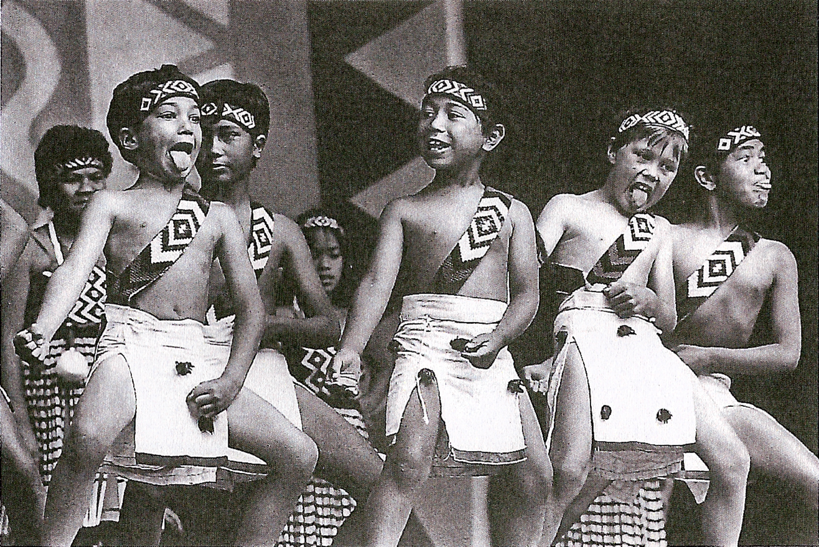

Task 1:

a. Take at least three photos for a news story and at least three photos for a feature article

→ approach the subjects of your stories according to group protocol and cultural expectations
→ ask your subjects politely and in a culturally acceptable way whether they are prepared to be photographed
→ ensure that each subject completes a confirmation form (see Appendix 1). Attach completed forms to the back of these instructions

Media Studies Department: Journalism unit standards verification

Name of person photographed Johnny Smith
Date 1/1/08
News story or feature (circle one)

The photographer did/did not ask me in a polite and culturally acceptable manner if I was prepared to be photographed.
The photographer has taken accurate records of the following:
Names |  | Addresses
Times |  | Purpose of photo
Location |  | Relation to story

Signature J Smith

1.1/1.3

b. Describe each photo and your reason for taking it.
Explain how it enhances or complements the story. These could include close-ups, interesting angle, unusual aspect of photo, sharp focus, good balance between subject/background, good framing/composition.
News story title

Kapahaka group does school proud

Photo file name: Kapahaka
I like this photo because all the kids in front are doing something and they look like they are enjoying themselves. One boy is on such a high that he has forgotten to stick his tongue out.
1.2

Task 2:
a. Select photos for publication
From the 6 photos you have taken for Task 1 you must select one to accompany the news story and one to accompany the feature.
Each photo must meet the following criteria

Criteria | Met
the photo has a dominant feature | 2.1 The front four kids are dominant in the foreground
the photo is sharp and the features are clear | 2.2 The front row is in sharp focus and clear, while the background performers are not so sharp

b. Record 3 ways the composition of the selected photo complements or enhances the story it relates to (could include angle, unusual pose, action shot, subject/background balance, composition, close-up of interesting detail or other well explained, valid reason – check with assessment schedule)

News story photo file name:
Kapahaka

1. As soon as you look at it, you know what’s happened and your eyes are on those kids. You’ve got an uncluttered background with a lot of darkness. It’s good that the people at the back are not so sharp because they don’t take your eye away from the people in front, but they do add depth.
2.3

Task 3:

c. Size or crop photos to enhance image

Record specifically how you will size and/or crop each photo to enhance the image. State two reasons for your decisions (could include removing unwanted material, emphasising particular subject material or enlarging an element of the photo etc.)
Save the cropped photo with the original.

News story photo:

I will size or crop the photo in the following ways:
I will crop the photo on the left-hand side

Reason1: I will crop the left side to remove the leg and arm of another performer because it looks cluttered, especially against the patterned background . 2.4

Assessment Schedule
Unit Std 10822

Evidence statements for all PCs are included in attached student exemplar.

Task | Element | Judgement | Met-News  Answer expected from student. (Partial answer only)
1 | 1.1 | 3 digital file photos submitted for news story  3 digital file photos submitted for feature story  Verification of protocols included. | 6 digital photos submitted along with verification sheets for each person in each photo
 | 1.2 | Photos are composed to complement or enhance the news story and the feature story  These meet at least 3 of the following:  Good close up study of subject; interesting angle of photograph; unusual aspect of photograph; sharp focus; good balance between subject/background; good framing/composition | Kapahaka photo is explained in terms of its framing and composition “kids in front are doing something..” As well as justified because of subject matter “One boy on such a high…”
 | 1.3 | Confirmation slip submitted from each subject which shows that appropriate details have been recorded – could include: date, time, locations, names, addresses, purpose of story, relationship to story | Verification sheets completed and submitted for each person in each photo
2 | 2.1 | The photo submitted has a dominant feature – could include: central figure, unusual angle, sportsperson in action, close up | The front four kids are dominant in foreground. Captures the action
 | 2.2 | The photo submitted is in sharp focus with clearly visible details | The front row is in focus and clear while the background performers are not as sharp
 | 2.3 | The photo submitted complements/enhances story angle through its composition – could include – close up study of subject, angle, unusual aspect, subject/background balance; framing/composition of subject | Kapahaka explained in terms of subject/background balance “You’ve got uncluttered background with lots of darkness…”
 | 2.4 | An explanation is submitted that explains how the photo will be cropped/sized to enhance the image – could include – removing unwanted material, focus more clearly on subject, enlarging | Kapahaka is explained in terms of removing unwanted material “Crop left hand side to remove leg…because it looks cluttered..”

